**User guide:  
A Quiz Game**

**User Guide for Quiz Game**

Welcome to my **Quiz Game**! This is a Python-based interactive game that challenges the players’ knowledge across multiple topics. Below is a comprehensive guide to help user navigate the game, use the interface, and understand how everything works.

**1. Starting the Game**

Upon launching the game, user will be presented with the **Main window** containing title of the game as a **Header**, an entry field where the user can enter a desired “player name”. Furthermore, the user can see his/her actual progress via the progress bar in the bottom left corner. Initially, it is set to “0/0”.

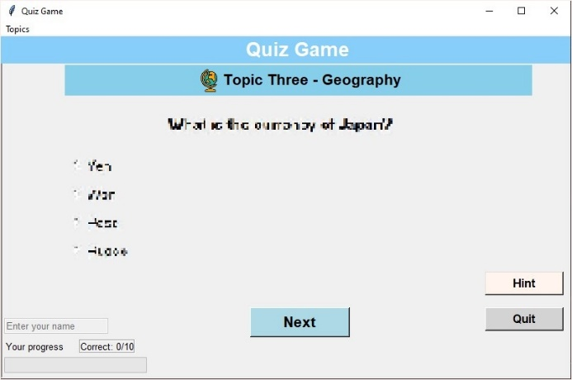After typing the desired player name the user is supposed to hover over the cursor to the **Menubar** and clicking onto the **Topics** drop-down/cascade menu and selecting the desired one among the options. The available topics will be shown by their names and icons. User can choose a topic by simply selecting them. A topic field will be highlighted in blue-colour once the cursor is being hover over it.

After selection has happened a check mark will indicate it on the left-side of the topic’s icon, furthermore, a new **Title label** will appear in the **Main window** right underneath the game’s header, and keep being shown it during the game. Otherwise, technically the game will load the corresponding-questions from that topic, and the quiz has started.

**2. Navigation**

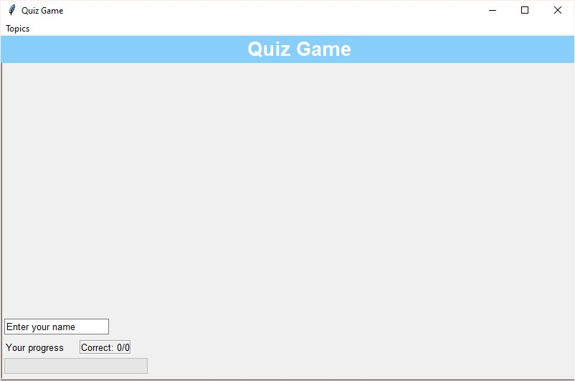**User Interface (UI)**: The main interface is loaded in the center of the screen as default, but the user can resize the screen by dragging its border or set it to full screen. The **main window** consists of several sections such as the **title bar, and topic title bar** at the top, the **question area** in the upper-center area, and the **related choices** listed below the question area.

There will be **buttons** below the questions and choices for user interactions, and a **progress bar** at the left-bottom corner to track quiz performance. The outer, inactive area after increasing the window will be shown in darker gray colour. It is supposed to help focusing on the game.

**Entering Your Name**: At the start of the game, user has the opportunity to enter a 20-character long name into a text box. This might be important, because after completing a round of the game, the player’s name will be recorded along with quiz results and the played topic’s name for later reference. Of course, the user can leave it as it is, using the default value, but during the game it cannot be changed.

**Progress Bar**: Once user has answered a question, the **progress bar** will be updated, and fill up based on user’s score. The progress bar shows how many correct answers the player has out of the total questions in the quiz. The **progress counter** next to the progress bar is supposed to show a textual representation of user’s score, like “Correct: 3.0/10.” Which means that the user will be prompted to answer 10 questions total and recently having 3.0 points for the evaluated answers.

**Buttons**: Below each question, user will find several buttons such as:

**Next Button**: After selecting an answer, click this button or press the Return key on the keyboard to proceed to the next question. The game will evaluate user’s answer and show whether choice was correct or incorrect.

**Hint Button**: If user need help, this button can be clicked to receive a hint about the current question. It will display a pop-up with a clue to assist user. But be careful, after each time hitting the hint button, it will decrease the user’s point by **0.5 point**!

**Quit Button**: If user wish to exit the game, click this button. It will close the quiz and end userr session without saving results. Otherwise anytime the user has to end up with playing, the Escape button can be pressed to quit and close the game.

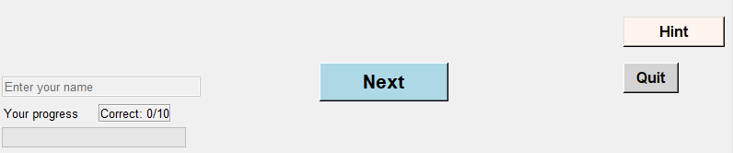

Each button changes its colour, while the left-mouse is being pressed on its area, and after releasing it and staying inside the button’s area the selected answer will be submitted.

**3. Answering Questions**

**Multiple-Choice Questions**:

There are two-type of question one with four possible answer choices, but among the movie-related questions the player will face with “True or False”-type cases. The choices will be displayed as radio buttons, hence, according to the ethimology of radio buttons, only **one** of the alternatives can be selected and submitted for evaluation. To select the desired answer, click on the radio button corresponding to choice’s line. Once user have chosen an answer, click **Next** to submit it and move on to the next question.

**Immediate Feedback**:

After clicking **Next**, the game will display feedback about whether user’s answer was correct or incorrect.

**Correct Answer Feedback**: If the choice is the correct one, a green-colored message, "**Correct! ✅**", will appear, indicating the user’s choice was the right one and earns **1.0 point**.

**Incorrect Answer Feedback**: If user answer incorrectly, an orange-colored message, "**❌ Next time!**", will appear. This lets user know that user’s choice wasn’t correct, but user can try again next time. Choosing the incorrect answer will not reduce the points earned so far!

**Visual Feedback**: In addition to the feedback message, the game provides a color change in the message box: **green** for correct answers and **dark** **orange** for the inaccurate ones. This color-coding allows the user to quickly see the results and helps in staying engaged during the quiz, besides of the slight, instant educational purpose.

**Progress Tracking**:

User’s score will be updated automatically after submitting each question by hitting **Next Button** considering if or how many times the **Hint Button** were pushed or not. The **progress bar** reflects the progress visually, while the **progress counter** (e.g., “Correct: 5.0/10”) shows current number of correct answers out of the total.

**4. End of Quiz**

Eventually, when all of the answers has been evaluated, the player will see his/her result in a messagebox with the following information:

**Total Score**: Your score is shown as a percentage, e.g., “Your score: 60%”.

**Correct Answers**: The total number of correct answers will be displayed, e.g., “Correct: 6.0”.

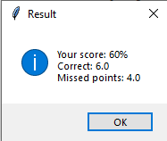**Missed points**: The total number of incorrect answers will be shown, e.g., “Missed points: 4.0”.

This **Result** messagebox provides a quick overview of the success rate in the actual round.

**Saving Results**: After displaying the results, the game saves the performance to a **result file** (*result.txt*), along with the given name and the topic’s name. This helps us track the progress over time and keep a history of the results time to time. After checking the result in the pop-up messagebox, the program won’t shut down, but after hitting “OK’ the game draws the user’s attention for having the chance to play another round using the same or a different topic as well.

**5. Achievement and reward**

**Achievement**: If at the end of quiz round the player has reached the perfect points, answering all of the questions perfectly the game will reward him/her.

**Bonus:** For answering perfectly a messagebox will pop-up to publish the good news of unlocking the “Topic BONUS” option in the drop-down menu with the same rules as the others’ and revealing its topic and appearance.

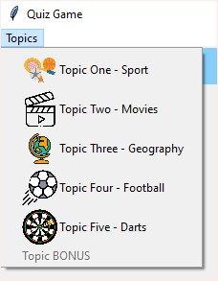**6. Topics**

The quiz game includes questions from the following topics:

1. **Sport**: General knowledge about various sports, athletes, and competitions
2. **Movies**: Films, actors, directors, and famous movie quotes are included in this topic
3. **Geography**: Questions related to countries, cities, landmarks, and physical geography
4. **Football**: Football-related questions, including players, teams, and history
5. **Darts**: Questions about the game of darts, its rules, and famous players
6. **BONUS**: Let it be a gift of the game specially for the player.

Each topic has a dedicated set of questions that user can answer. After selecting a topic, the quiz will load a series of questions from that category.

**7. Results**

**Viewing Results**: Once the quiz is completed, results are saved to a file named *result.txt* to the same folder where the program is. Although there isn’t a separated ranking system, players can open the *result.txt* file anytime to see them as a history log in various topics.   
**A result note consists of lines of information** such as:

1. 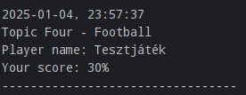Date and time
2. Played topic’s number and name (same as in game menu)
3. Player name
4. Score of the round in percentage
5. Separator line